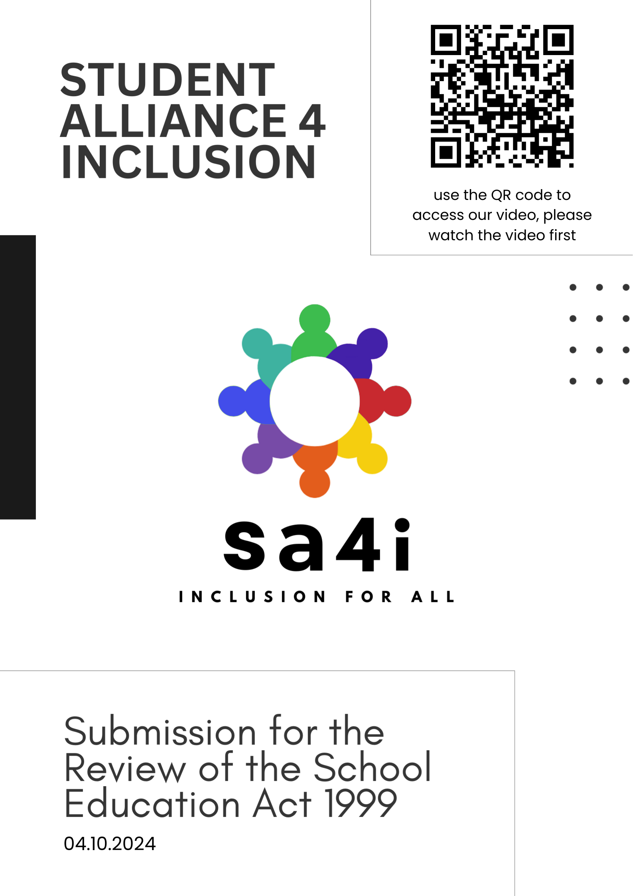

CONTENTS
Introduction 3-5

Introduction to the Organisers 3
Introduction to the Project 3-4
Introduction to the Experiences of Disabled Students in WA 4-5
Introduction to the Importance of Change 5

Part 1: Insights Shared by Students 6-25
Section 1: Inclusion is for Everyone 7-11
Universal Design for Learning 8-11
Section 2: The Choice Between Being ‘Supported’ and ‘Included’ 12-19
Benefits of Inclusive Education 16-18
A Clear Right to an Inclusive Education 18-19
Training for Educators on Inclusive Education 19
Section 3: Valuing Authentic Disabled Student Voice 20-21
Obligation to Communicate, Consult and Collaborate with Students & Parents 20
The Disabilities Advisory Panel and Other Advisory Groups 21
Section 4: Clear Responsibility for Realising Inclusive Education 22-25
Data Collection 23-25

Part 2: Responses to Discussion Paper Questions 26-34
Response to Question 1 26-27
Response to Question 2 27-28
Response to Question 3 28-29
Response to Question 4 29
Response to Question 5 29-30
Response to Question 6 30
Response to Question 7 30
Response to Question 8 30
Response to Question 9 31
Response to Question 10 32
Response to Question 11 32
Response to Question 12 32-34
Response to Question 13 34

Conclusion 35

Introduction to the Organisers
This submission was written by the co-founders of the Student Alliance for Inclusion. Our names are Ruby Habib and Laura Panetta, and together with 27 other students with disability in Western Australian schools, we’ve collected authentic student voice about how the School Education Act 1999 (SE Act) should be amended to ensure the right to an inclusive education is met for all students.
Introduction to Ruby Habib: My name is Ruby Habib, I am sixteen years old and was born with a physical disability (congenital upper limb loss.) Currently in year 11, I have been progressing through the WA education system for over a decade and have experienced firsthand the positives and negatives of WA schooling. In my personal experience, I have faced many barriers regarding inclusion at school and have spent a lot of my childhood advocating for myself and my needs. I believe that everyone deserves a valuable and enjoyable school experience from kindergarten all the way through to year 12 and beyond, and it is my belief that this is possible with the right adjustments to the SE Act and the willingness and openness to change.
Introduction to Laura Panetta: My name is Laura Panetta, I am sixteen years old, and I am non-disabled, but I’ve always been really passionate about the rights of people with disability. My younger brother has Down Syndrome, so access to an inclusive education has always been something I’ve believed is essential to improve in Western Australia, to ensure realisation of the rights guaranteed to students with disability under the Convention on the Rights of Persons with Disabilities. I’ve lived most of my life watching my peers with disability having to fight within the system for there needs to be met, and I think that it’s time the SE Act is amended to recognise and welcome students with disabilities in the classroom and school community and realise their right to an inclusive education. I really believe student voice is so important in education, so I think that, by listening to the feedback and the voices of students, Western Australian’s education can be high quality, meaningful, accessible and inclusive for every student.
Participating Students:
Ruby, Laura, Emily, Matilda, Eleanor, Mimi, Robin, Sam, Daniel, Frank, Henry, Zeb, Julius, Tom, Sam, Drea, Cooper, Ryan, Ethan, Kayden, Wylder, Sofia, Luca, Mara, Natalya, Hayley, Zac, and two anonymous students

Introduction to the Project

Upon the announcement of the review of the SE Act 1999, we decided to create a submission with the participation of students from around WA to show the changes students believe need to be made to make the Western Australian education system accessible and inclusive of students with disabilities and provide them with meaningful and equitable education.
The submission was contributed to by 29 students, all of whom are actively supporting a change in the way the education system operates to include students with disability. The students all opted to either participate in a video interview, or to send us a written statement. All students who gave video interviews are in the video submission that accompanies this written submission, and students who sent us written statements may either have their voices heard in this written submission or the video.
The submission was entirely student run and only contributed to by students. All students who contributed are disabled, with the exception of Laura Panetta. The students wanted to showcase and highlight their own experiences as disabled students in Western Australia, as well as the pattern that all of their experiences together show – a pattern that highlights the dire need of WA schools to shift towards inclusive education. The students who contributed were between kindergarten age and year 12 age, with the exception of one ex-student who graduated in 2023.
Structure of the Written Submission: This written submission contains two parts. Part 1 is a summary of the areas students identified need to change within the education system, and Part 2 is more detailed, with specific answers to the questions provided in the Discussion Paper. In Part 2, there may be reference made to sections in Part 1, if the content of student feedback aligned strongly with the question.

Introduction to the Experiences of Disabled Students in WA
What this project found was the clear and resounding fact that many students in Western Australia are forced to choose between being included in the classroom and being supported in the classroom. Students detailed that their experiences of support and inclusion have been, largely, mutually exclusive in Western Australian schools, and that, in the rare instances that they have felt included and supported in the same environment, it is usually due to a certain teacher or group of school staff personally dedicated to inclusion – it isn’t the Department of Education structures that are facilitating the inclusion, rather it is the staff personally facilitating inclusion because it aligns with their personal values.
Students were also asked about the times at school when they felt the most included, and the students echoed the sentiment that they felt most included when they were supported to learn with their peers, disabled and non-disabled, and when their schools worked with them, instead of against them, to understand their needs and how to include them in the classroom, to help them achieve the best outcomes and access to highest quality education they could.
Students highlighted the barriers to even the most basic accessing of education in mainstream schools, with several students highlighting the number of schools who had told them that their mainstream school was not ‘the best fit’ for them. Some students participating are even homeschooled as the education system has pushed them out or provided such a low quality, often traumatising education, that they feel they cannot access an inclusive education at school, so the burden is put on the student and their parents to supply that education.
Students also drew attention to the idea that inclusion is for everyone, and that inclusion benefits all students, regardless of disability or not. Students spoke about making the schooling environment inclusive for all students, and setting inclusion as a basic standard of education, rather than an occasional ‘add-on’ for when a student doesn’t fit the ‘norm’.
Disabled voice in educational decision making was a key area that many students wanted to see improvement on. Students wanted to have more voice and agency, not only in their own education and in the way their schools work with them, and not against them, but also on a higher level. Students with disability want to see disabled people have input on Education Department wide decisions, and students with disability being consulted on significant issues. Disabled students want to have input at all levels and to have their voices and opinions genuinely taken into account.
All of this has been reflected throughout our video submission and will be addressed in more detail further in this written submission.

Introduction to the Importance of Change
Western Australian schools and the statewide education system do not cater for or include students with disabilities to a great extent. Listening to the voices of disabled people in this review of the SE Act is crucial to changing our education system for the better, as disabled people are ultimately the experts on disability and their own education, and they provide really valuable insights into the ways in which the system can be changed.
As of 2018, an estimated 1 in 10 students in Australia had a disability. This is likely a significant underestimate because disability is more than a medical label – what matters is how an individual student is affected by their learning environment and we all know that much more than 1 in 10 students need adjustments and support. The SE Act may only influence Western Australian students, but that is still a very large number of students who are affected daily and will go throughout the rest of their lives carrying the experiences they had in Western Australian schools. It is beyond important to ensure that the SE Act is inclusive of disability and sets in place a system wide framework that acknowledges, accepts and embraces the rights of disabled students to an inclusive education, so that every student in WA can receive a high-quality education, and be socially and academically supported.
PART 1
Insights Shared by Students
The following section is a summary of the main themes and messages expressed by students through the video interview process and the collection of written statements.
The ideas and the concepts in the following section were echoed across the entire student group participating, showing how deep and widespread the need for change is in Western Australian schools. Students came from a range of different schools, with different disabilities, and different experiences – but the desire to see reform remains consistent across the system.
Here are the messages echoed by students that will be discussed in Part 1:

Section 1: Inclusion is for Everyone
Section 2: The Choice Between Being ‘Supported’ and ‘Included’
Section 3: Valuing Authentic Disabled Student Voice
Section 4: Clear Responsibility for Realising Inclusive Education

Section 1: Inclusion is for Everyone
Echoed throughout the video interviews was the idea that ‘inclusion is for everyone’ and that inclusion does not benefit only disabled students, but rather the larger student and even school community.
Inclusion is often discussed in a disability or minority focused lens. It’s discussed in the sense of changing a pre-existing education model to expand to capture other students, but that is much more characteristic of ‘integration’ than it is of true inclusion. Students want to see the framework of the education system change to see inclusion as the norm, to seeing the concept of including, understanding and supporting applied to all students, rather than just students with recognised disabilities or of minority group status. Students want to see a classroom that is welcoming, safe and valuing of every student, rather than a classroom that shifts to integrate a disabled student, without actually changing any of its underlying structure and issues that made it inaccessible in the first place.
“Everyone has the right to have education and have the same opportunities to learn. It doesn’t matter who we are or where we come from, we’re all humans and we all deserve to be treated with respect.”
- Daniel, age 16
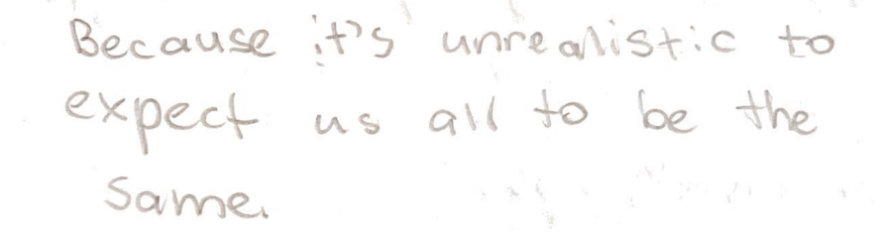

- Natalya, age 13
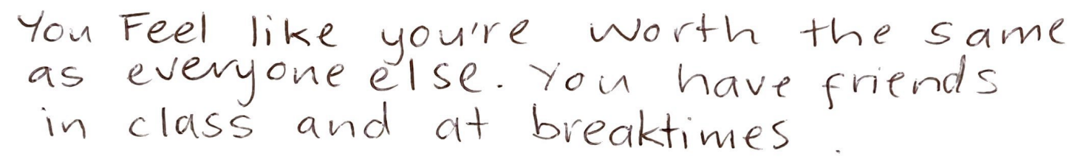

- Zac, age 15
Universal Design for Learning (UDL) is key for this. To adapt to the model of inclusion that shows that inclusion is for everyone, schools should embrace Universal Design for Learning.

Universal Design for Learning (UDL)
[referencing Question 5 and 7*]
UDL describes the idea that the education system should be universally accessible and inclusive of every student, and that this should be reflected in the practices of schools.
All classroom activities should be accessible to all students. It should not be a matter of changing the classroom upon the arrival of a disabled student, rather, as a base, the classroom should be welcoming, accessible and inclusive of every student. This should include:

Teacher Instruction that is Easily Understandable to All Students
Teachers should be using visual prompts and other methods to make the message clear to all students. Instruction should not be overcomplicated, and teachers should be willing to explain instructions further if students require it.

Class Activities that Can Be Adjusted to Fit the Needs of the Student
Classroom activities should be set at the level of the students in the class. This means designing class activities through an inclusion lens and ensuring that the activities can be easily adjusted to fit the needs of the student, while still keeping all students learning on the same topic, so that they can interact with each other about the work and there isn’t a clear divide in who is doing what content. It’s differentiation, not completely different content.

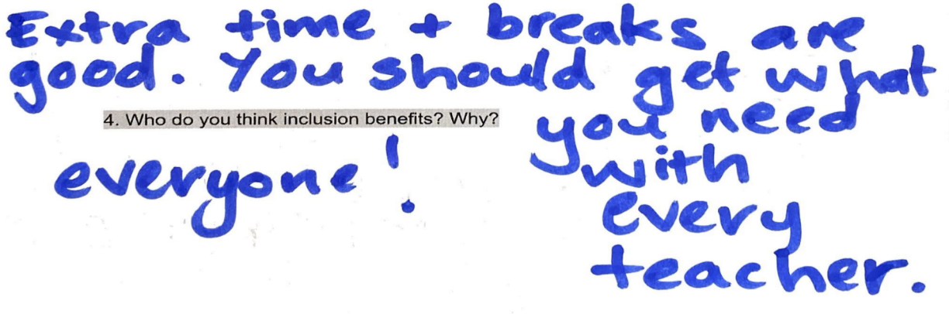

- Hayley, age 12
“Fair isn’t all the same, it’s what you need.”

- Cooper, age 9

Working with Students
Schools should work with students with disability, and all students, to understand what would make education more accessible and inclusive for that particular student. This should include consultations with the student and their family on a regular basis and making sure that classroom teachers are aware of the adjustments that should be made for the student and how to implement them well. Classroom teachers and disabled students should be actively involved in this process because ultimately, they are the ones in the classroom who will be implementing the ideas.
“I have felt very included this year by my teacher, because she is very flexible about decisions, and she lets us learn wherever we want in the class and lets us have brain breaks whenever we need them.”
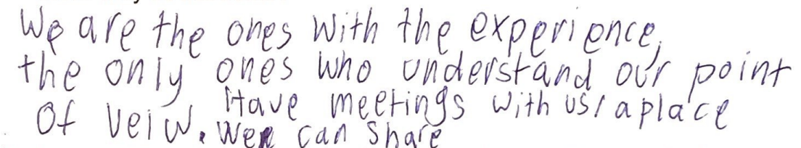
- Wylder, age 8

- Mara, age 16
- Mara, age 16
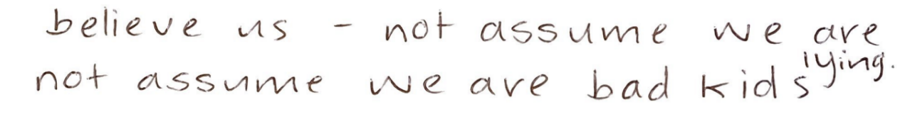

- Anonymous boy, age 13

Chill Out Spaces/Quiet Spaces
Ensure that the school environment has chill out spaces or quiet spaces for students to access when needed – not just necessarily students with disability. Chill out spaces provide students with a safe and calm environment for when they are overstimulated, and the classroom environment is inaccessible to them. While these spaces are very helpful and many students who participated described the benefits that chill out spaces have for them, these spaces should be complimentary to the classroom and should not replace the class environment. They should be accessed only when the classroom is not accessible for a student due to the student being overstimulated in that particular moment, but the classroom should be made as accessible as possible to minimise the time students spend in the chill out rooms. It should be an option for students, but schools should not push students to use that space instead of the classroom.

Considerations Surrounding Pathways
There should be a rethink around how schools prepare disabled students for meaningful employment, and how the system assesses students with standardised testing for post-secondary education.
Students would like to see a clear obligation on schools to work with students and families to create post-high school transition plans that lead to meaningful employment. Students want to see collaboration between themselves and their schools to create well thought out, inclusive pathways plans to ensure that their schools are preparing them for after their school years have ended. Students want to see schools helping students find real employment within their communities.
These transitions should not be planned at the last minute, but rather on a longer-term basis and as a dedicated plan – and those transitions not being towards shelter workshops or volunteer jobs, but rather towards real jobs, in the community, with real pay. Transition planning must be with high expectations and respecting the desires of the individual student. People with disability need to be economically secure too, and schools need to ensure that they are preparing students for economic security.
Additionally, schools need to be providing adequate adjustments for students to be able to take standardised tests, and other tests, such as WACE exams, to ensure that students with disabilities aren’t arbitrarily disadvantaged by a lack of accessibility. These tests can be incredibly important for all students in their goal of achieving economic stability, so it is crucial that these tests are accessible to all.
For in-school testing, students should not be disadvantaged by inaccessibility that teachers and the school itself could prevent by making reasonable adjustments for the student, such as extra time, different modes of answering (i.e. spoken answers, typed answers), breaks and other easily implemented adjustments.
For testing controlled by the Schools Curriculum and Standards Authority (SCSA), such as Online Literacy and Numeracy Assessment (OLNA) tests and Australian Tertiary Admissions Rank (ATAR) tests, it is essentially that SCSA, under the SE Act, is required to follow an inclusive education framework and principles to ensure inclusive and accessible outcomes for all students.
While other students often stress about their SCSA tests due to a lack of knowledge on their curriculum content, many students with disability instead have to fear lack of accessibility to demonstrate their knowledge, which is not something a student should have to worry about. If a student cannot demonstrate their learning on a test because the test is inaccessible, that disadvantages the student and puts them at an ‘unequal level’ relative to their peers. Especially for tests connected to ATAR, where students are ranked based largely on their end of year exam scores, if the exams themselves aren’t accessible, this puts the student on an unfair playing field, meaning not only do they have to study, but they have to do their best to battle within a system that was never designed to cater for their diverse needs.
SCSA must have an obligation to work with, not against, students with disability and their families to ensure that students are not disadvantaged by the systems they have in place, and SCSA must also have a requirement to facilitate any adjustments the student may need, in accordance with their right to an inclusive education. These tests, such as OLNA, are often crucial for a student to achieve their Western Australian Certificate of Education, so it is imperative that they are accessible to all students.
“I didn’t complete most tests and exams because I was running out of time. It wasn’t because I didn’t know the content, it was just simply that it took me a lot longer, and the time wasn’t enough. A lot of the time I would know the content, like in chemistry, most of the time I’d get about 90%, a pretty high grade, but when it came to the exam, I would get more like 60%, maybe in the 50s, just because I was not finishing it. It wasn’t because of the hard questions, because sometimes I would do those sometimes at the start, and it wasn’t about strategy because I was constantly working on how to get faster, and that’s what I talked about with my teachers. Always how do I do this faster; not how do I get better at this content. It was always about speed, and it was always very frustrating because I didn’t get to show what I knew or what I worked hard for, and I found it very unfair.
Accommodations are currently limited for students with disabilities. They need to be made more flexible to include things such as the use of laptop, even more extra time, or voice to text, to allow it to be more fair and reflective of what they can do.”

- Sofia, age 18

Section 2: The Choice Between Being ‘Supported’ and ‘Included’
Many students who participated in this submission described experiences of feeling that they had to choose between being supported and included in the WA education system – and for some of them, neither of the two were accessible.
Many students who participated were homeschooled, simply because their experiences in the education system had left them feeling and believing that they could not access an education without a traumatising experience. Some students even described their local government schools essentially turning them away, by suggesting that they did not have the capability to educate them. Other students described being taken out of the classroom incredibly regularly for disciplinary measures. Unfortunately, this is a reality for many disabled students. This constitutes exclusion under General Comment No. 4 on Article 24 of the Convention on the Rights of Persons with Disabilities (CRPD).
Source: United Nations General Comment No. 4 on Article 24 of the CRPD
Exclusion occurs when students are directly or indirectly prevented from or denied access to education in any form.
Below are some stories from students we interviewed about their experiences of exclusion in Western Australia. The following two stories describe students being excluded from their classes and their education for long periods of time due to being failed by the disciplinary system.
“In Year 2, there was this ladder system where at the bottom it said, ‘principal’s office and at the top it said ‘superstar’ and I was always at ‘principal’s office’ and I always got blamed for things I didn’t do. I felt very very upset because I was always in the principal’s office, and I hardly learnt anything because I was there all the time, and I didn’t know what I did wrong. But then, when I was in class, which wasn’t very often, I watched all the kids go up to ‘superstar’, and I was never there, so I felt a little bit upset that the teachers were just like… it felt like they were targeting me. Because I missed out on so much school because I was in the principal’s office in Year 2, I started tutoring because of how much schoolwork I missed from Year 2, I really struggled.”

- Wylder, age 8

“A lot of the time, I’ll be suspended so many times because I’ve gotten overwhelmed and overreacted, apparently – because I’m not good enough for the school, so that’s caused me to be suspended so many times, and that’s equalled me to be close to having to be expelled, so I’ve had to move to lots of different schools because of my disability and my needs not being met. I’m always being told that I have to be suspended, or losing my good standing or almost being expelled, because I’m different and my needs aren’t being met.”

- Matilda, age 11

The two statements below come from two students who were denied access to an inclusive education and excluded from their schools. The first student was ‘turned away’ by his local schools, and the second student was not included or supported while attending a WA school, so his family turned to homeschooling. Multiple participants in this submission are now homeschooled due to their needs not being supported or recognised by their schools, including by their local government schools.
“My local school told my mum I would be a ‘small fish in a big pond’ and I would ‘drown’ unless I had a diagnosis for funding to provide support. 12 schools said I was not suitable for their school because of my disability.”
- Ethan, age 16
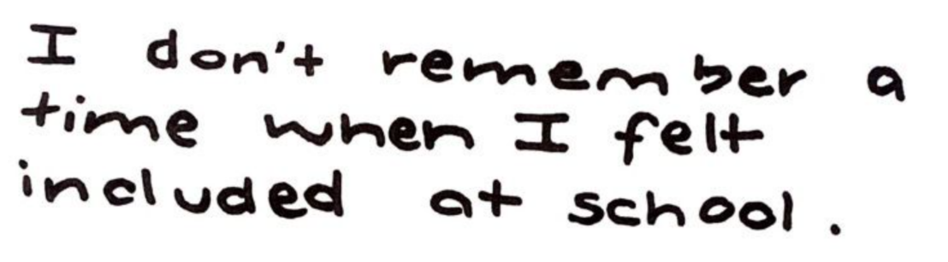

- Ryan, age 10

The stories of these students highlight the necessity of this SE Act review and highlight the dire need to change Western Australian schools to become places where students with disability are not actively turned away or traumatised by their schooling, to the point where their only option is to be educated by a parent at home.

Students should not be forced to choose between an education where they feel socially and academically included in the classroom, or an education where they are supported. Many students described that they had the option of being ‘supported’ in segregated classroom settings, but then couldn’t access any form of true inclusion, constantly being isolated with the same groups of only disabled students. Often the ‘support’ provided in these settings was also not catered towards the students, and the staff also lacked training in inclusion and properly listening to students about their needs, and how to make their education accessible.
Some students spoke about being forced to change schools regularly because their schools were not supporting them, and they were often facing disciplinary actions which made it very difficult to participate in school. Many students also spoke about being separated from non-disabled students and being socially isolated in their education. This constitutes segregation under General Comment No. 4.
Source: United Nations General Comment No. 4 on Article 24 of the CRPD
Segregation occurs when the education of students with disabilities is provided in separate environments designed or used to respond to a particular or various impairments, in isolation from students without disabilities.
Many students expressed that they had the option of being in a classroom with other students with and without disability and feeling included, but when in that classroom setting, their schools were not academically supporting them, or their schools were not adequately trained or prepared for disabled students, so their educational outcomes would often be hindered by lack of supports, and lack of knowledge around the student’s needs – often resulting in arbitrary disciplinary measures being taken against a student when they tried to communicate that they weren’t being supported. This falls under the definition of integration under General Comment No. 4.
Integration is a process of placing persons with disabilities in existing mainstream educational institutions, as long as the former can adjust to the standardized requirements of such institutions.
Source: United Nations General Comment No. 4 on Article 24 of the CRPD

Disabled students essentially described that they either had to choose between being supported to learn in the classroom and access education and being a part of their community and included socially. This is a choice no student should have to make, and directly breaches Article 24 of the Convention on the Rights of Persons with Disabilities (CRPD).
Source: The United Nations Convention on the Rights of Persons with Disabilities
Article 24.1 of the CRPD provides:
“State Parties [including Australia] recognise the right of persons with disabilities to education. With a view to realizing this right without discrimination and on the basis of equal opportunity, State Parties shall ensure an inclusive education system at all levels … .”
Article 24.2 of the CRPD provides:
“In realizing this right, State Parties shall ensure that:
- Persons with disabilities are not excluded from the general education system on the basis of disability, …;
- Persons with disabilities can access an inclusive, quality and free primary education and secondary education on an equal basis with others in the communities in which they live;
- Reasonable accommodation of the individual’s requirements is provided;
- Persons with disabilities receive the support required, within the general education system, to facilitate their effective education;
- Effective individualised support measures are provided in environments that maximize academic and social development, consistent with the goal of full inclusion.”

The inclusion guaranteed to people with disability in the above article is defined, again in General Comment No. 4, as:
Inclusion involves a process of systemic reform embodying changes and modifications in content, teaching methods, approaches, structures and strategies in education to overcome barriers with a vision serving to provide all students of the relevant age range with an equitable and participatory learning experience and environment that best corresponds to their requirements and preferences. Placing students with disabilities within mainstream classes without accompanying structural changes to, for example, organisation, curriculum and teaching and learning strategies, does not constitute inclusion. Furthermore, integration does not automatically guarantee the transition from segregation to inclusion.
Source: United Nations General Comment No. 4 on Article 24 of the CRPD
- Sam, age 16
“Inclusion is a priority. There is no room for segregation. There is no room for having kids put in special wards where they are viewed differently. It doesn’t matter if they use the same play equipment, it’s important to have kids in the classroom with their non-disabled peers from age kindy to year 12. That’s essential. And then, above that, not just including the kids and having them be in the room, but having them feel seen in the room, making the room safe for them.”

Benefits of Inclusive Education
Inclusive education has extensive benefits, not just for students with disability, but for students without disability as well. Inclusive education ensures that every student becomes valued and respected members of their local communities. When students learn with other students from diverse backgrounds with diverse disabilities, students become much more understanding (i.e. empathetic) and accepting of difference in general (i.e. tolerant) and learn how to participate in and foster a culture of inclusivity that welcomes difference (i.e. welcoming). This has large scale effects, not only for people with disability, but for other vulnerable groups in society who are able to feel safer and more welcome in communities where difference is understood and accepted.
“It is easier to have a variety of different people in the classrooms, every classroom, disability, no disability, people from different cultures and stuff like that. At younger ages it is really important that they grow up and then are like ‘yep, that’s okay, that’s just how people are, everyone’s different, that’s how I grew up’, instead of going like ‘ah this is what people are’ and later on in life, meeting someone who is different and saying ‘this doesn’t make sense, who are they and do I have to treat them differently?’”

- Matilda, age 11
Inclusive education fosters meaningful connections between students, both with and without disability. This culture of inclusivity and acceptance extends further than just non-disabled students knowing of disability, but rather is about students with disabilities, and students of diverse backgrounds, being valued for themselves, being accepted and acknowledged as community members in their own right, and it’s about relationships of mutual respect. Inclusion is connection.

“I like having my needs met at a mainstream school where I don’t feel as socially isolated. As an older disabled student, I’ve taken on a leadership-like position, in a lot of environments, where I like to help kids who I look at and go ‘that kid is just like me’ and a lot of the time I have actually helped them and got the help I wish I would have gotten. Mentorship between students is really important.”

- Robin, age 16

Having both disabled and non-disabled students also allows for increased opportunities for mentorship and peer tutoring, which has beneficial outcomes for the disabled students who are often the receivers of the mentoring from other students, but also for non-disabled students, who have more opportunities to improve their ability to communicate and their empathy. There is even more mentoring opportunities for students with disability, typically older students who have the opportunity to show leadership in supporting younger students with and without disability within the school.
“Not just having people learn about us, but us learn about them. People learn about each other and about how we’re different, but also how we’re the same, so it builds some kind of connection.”
- Daniel, age 16

Inclusive education benefits every student. If a classroom is universally accessible, it is welcoming of every student. It acknowledges and respects the rights of every student, which has ramifications not only for more vulnerable students, whether that be students with disability, students with diverse cultural backgrounds, students of different socioeconomic backgrounds, or any other group membership, but a universally felt and recognised benefit for every student in Western Australia.
Students who respect each other and their differences are students who form meaningful social connections – which is something many students who participated in our submission described as lacking. Many students described social isolation, and its effect, and how being truly included could not only be beneficial for their mental health but is really important in creating a desire to come to school and to learn.
- Luca, age 15
“Inclusion is important because everyone deserves friends and shouldn’t be lonely. Being included at school feels like you’re with someone and have at least one friend or a group or kids and you’re not by yourself.”

Students believe that the following should be implemented to ensure that their right to an inclusive education is realised:

A Clear Right to an Inclusive Education
Students believe that there should be a clear, specific right to an inclusive education embedded within the SE Act, to ensure that they cannot be prevented from accessing it, and that there is clear responsibility placed on schools to provide an inclusive education to all students.
Schools need to be aware that they have the duty to, not only allow the student to access an education and enrol at the school, but also to actually make sure the education that student receives is an inclusive education and is in accordance with that student’s rights under the CRPD, which Australia is a signatory to and has ratified.
To achieve this and have this implemented in the SE Act amendments, there does, however, first need to be the basic, clear right for students with and without disability to enrol at their local government school within the SE Act [*referencing Question 4]. There needs to be a clear acknowledgment of this right, and it needs to be clear that schools cannot refuse a student with a disability, or any other student from enrolling at the school and should not attempt to politely or impolitely refuse the student either – their needs to be consequences for schools who attempt to breach the student’s right to enrol.
This right to enrol at their local government school should apply to all students, regardless of disability. Many students who participated in this submission have membership in other communities, whether they are from diverse backgrounds or have gender and sexuality diversity, it must be acknowledged that local government schools must guarantee the right to enrol of every student, regardless of any difference or group membership, and this should be expressly stated in the SE Act.
As students with disability are the most at risk of being excluded, it would be beneficial if the section about this right read “the right of every student to enrol in their local government school (including students with disability)”, to make sure everyone knows and understands the particular importance of this right to students with disabilities.
- Zebedee, age 14
“Every child deserves a right to education. Why is someone with a neurological or physical disability any different? Some kids might start to wonder ‘why am I so different?’, ‘why isn’t the world treating me for who I am?’ or ‘am I the problem?’ I don’t think that’s a mindset that anyone should have, because you’re never the problem, no child is ever the problem – it’s always something else. It’s so important that the School Education Act gets revised, because there is an entire demographic not getting the education they need, because they’re being forced to conform to a school system that was made 200 years ago.”

Training for Educators on Inclusive Education
Currently, there is no legislated requirement for educators to have any knowledge surrounding inclusive education practices, and how to support students with disability. There is no requirement for educators to even have any knowledge or training around disability at all.
Educators should have mandatory training on inclusive education practices, and this training should be undertaken regularly to ensure that their knowledge and skills align with current standards and human rights principles.
The SE Act should be amended to specifically require that all school staff (including principals and deputy principals) involved in providing education to students complete training in inclusive education practices as part of their university education courses and on a regular basis afterwards. Inclusive education, to be successful depends on principals and deputy principals showing leadership and support for an inclusive school culture, and that is why it is important that they also undertake inclusive education training.
“Inclusion is important because everyone deserves an education. Being included at school feels good. It’s when your teacher knows how your brain works.”

- Anonymous boy, age 11

Section 3: Valuing Authentic Disabled Student Voice
Students spoke about the need to have more disabled voice present in education. Students discussed disabled voice on all levels, both within schools and Education Department wide. Students discussed the need and the desire to feel more heard in their own education, from the classroom to the system wide decisions being made by the Department of Education.
On a school level, students need to be consulted in their own education to ensure that their needs are being catered for and that their voices are being heard and considered. As it stands, the SE Act only discusses the importance of parents in education and decision making but doesn’t actually acknowledge the student. Students with disability are the experts on their disability, their needs and the way their brains work, and that needs to be acknowledged, and their feedback needs to be taken into account and valued.
Students need to have an active role in their individualised education plans, and need to feel comfortable and heard, so that they are empowered to give honest feedback on what is and what isn’t working for them. Schools need to be actively seeking the feedback of their students, as many students reported not feeling heard, or having their feedback ignored, discouraging them from providing more input.

Obligation to Communicate, Consult and Collaborate with Students & Parents
[referencing Question 8*]
The SE Act should be amended to include a clear duty of schools to consult with students and their parents. Section 3 of the SE Act, Objects of Act, already contains mention of the “involvement and participation of a child’s parents in the child’s education”, but this still only acknowledges the “importance” of the involvement and participation of parents, rather than any formal requirement to do so.
“to acknowledge the importance of the involvement and participation of a child’s parents in the child’s education;”

Source: Section 3: Objects of Act of the SE Act
It doesn’t contain any obligation of schools to communicate, consult or collaborate with students with disability and their parents. While the phrase “child and child’s parents” should replace “child’s parents” in Section 3, this is still a minimal attempt at legislating the involvement of students and their families. The SE Act should contain an obligation for schools to communicate, consult and collaborate with students about their education, as well as with their families.
- Sam, age 16
“The feedback that comes back from students should be taken really seriously and action should be taken quickly.”
“Trust us, we’re the experts on our own disabilities. We’ve lived our lives, no one knows themselves better than disabled kids do. Just asking kids what they need, and listening, and actually recognising that what they say matters. I believe that teachers should not necessarily view themselves as experts, but as collaborators with the kid, to help them to get to where they want to be in life. When it comes to disabled kids, the people who should get a say in how we live our lives is us. Nothing about us, without us. That applies even if a kid is 5, because they still have feelings, and their feelings still matter, and it is fundamental to any reform to make the community it effects [disabled students] feel listened to.”
- Ruby, age 16

The Disabilities Advisory Panel and Other Advisory Groups
[referencing Question 11*]
Students expressed that disabled voice should be crucial in system-wide decisions. Disabled people should be regularly consulted on policy, and should be active members on boards, panels and advisory groups throughout the Department of Education, not necessarily just in groups that are disability focused.
As such, thinking around inclusion and how policy may affect or has affected students with disability should be part of the everyday operations of the Department of Education, not just a matter for the Disabilities Advisory Panel. Rather than having a Disabilities Advisory Panel that includes no quota for disabled membership under the SE Act, there should be a quota for disabled people on non-disability focused panels such as the Attendance Panel and the Discipline Advisory Panel. This would ensure that disability is being considered in all areas of education, and that the effect on disabled students of Department of Education policy is considered in every space. The people who should be sitting on these panels should be both people with lived experience of disability, and those with expertise in inclusive education.
Alternatively to a Disabilities Advisory Panel, there should be an Inclusive Education Advisory Panel, which focuses on making education accessible and inclusive of all students, not just disabled students, as inclusion benefits every student (see discussion in Section 1 of Part 1). The SE Act does not currently even outline the function of the Disabilities Advisory Panel, if an Inclusive Education Advisory Panel is implemented, it would be imperative that its functions be outlined clearly within the SE Act. Those functions should include providing advice in relation to inclusive education and reviewing decisions about reasonable adjustments.
Section 4: Clear Responsibility for Realising Inclusive Education
[referencing to Question 6*]
Students spoke about the need to have clear and defined roles and responsibilities, to make sure that there is clear onus on who is meant to be actively implementing inclusive education, so that there can be checks and reviews on the progress of implementation, and increased accountability.
Throughout the SE Act, in sections relevant to the roles and responsibilities of different groups within the Department of Education, there should be explicit mention of the duty to realise students’ rights to an inclusive education.
This responsibility should be held by everyone in the education system, from the CEO of the Department of Education to education assistants in classrooms (and the principals and teachers in between). The CEO and the Department of Education should be accountable for the implementation of system-wide policies which improve access to inclusive education, principals should be responsible for ensuring that the practices in their schools align with the right to an inclusive education, and educators should be responsible for ensuring that their classrooms are inclusive, and their teaching is accessible.

Suggested Amendment to Section 61: CEO’s functions
Insert a paragraph under subsection (1) which reads:
“facilitate the implementation of inclusive education policy and ensure the implementation of inclusive education practices;”

Suggested Amendment to Section 63: Principal’s functions
Insert a paragraph under subsection (1) which reads:
“facilitate the implementation of inclusive education policy and practices;”

Suggested Amendment to Section 64: Teacher’s functions
Insert a paragraph under subsection (1) which reads:
“facilitate the implementation of inclusive education practices;”

Data Collection
[referencing Question 13*]
The Department of Education should increase its requirements for data collection relating to inclusive education. Schools should be required to collect data surrounding the participation and outcomes of disadvantaged or vulnerable student groups in schools to get a better understanding of the inequity across the system and to see the impacts of policy on students, and whether that policy is helping to actualise their right to an inclusive education.
Data should be analysed both on a school level, to ensure that individual schools are providing high quality, inclusive educations to students, but also on a system-wide level, to ensure that the policy of the Department of Education is consistently improving access to inclusive education, and progress is trackable. This would keep both schools and the Department of Education more accountable for and aware of their progress in realising inclusive education for Western Australian students.

Data About Discipline
Data should be collected about exclusions (suspensions and expulsions) for all students to show how often students are being excluded from the classroom. There, however, should be specific data compiled to show the exclusions of particularly vulnerable student groups, like students with disability, to show the level of exclusion of vulnerable students, and whether this level is higher than that of the broader student population. This data should be collected at a school level, to show the proportionality of exclusions within each school, but also on an education system-wide level, so that data can indicate the equality of exclusions across Western Australia. This data will help to guide policy and initiatives to help reduce unequal disciplinary outcomes, and to investigate the reasons why there may be higher rates of exclusions for some groups of students.

Data About Attendance
Attendance data should be collected, as it already is for the Attendance Panel, but there should be more specific data analysis for more vulnerable groups. Having a legislated obligation to analyse data will cause more thought and more consideration to be given to why there may be lower attendance for more vulnerable groups, such as students with disability. This would highlight unequal participation in the system and may shed light on situations preventing students from attending school and accessing an inclusive education.

Data About Learning Progress
A key cornerstone of education is the learning itself. Standardised testing is often very inaccessible to many students with disability, and either does not show the full potential of a student, due to adjustments being too minimal for the test to fully demonstrate the abilities of the student, or doesn’t demonstrate the student’s ability at all, as many students with disabilities are excluded altogether from standardised testing, as it is simply too inaccessible to them. Due to this, it can be hard to tell whether any meaningful progress is actually being made in the student’s learning.
To ensure that there is still data to show learning, it is essential that there is data collected around learning progress, so that both on a school level, and a system level, there is accountability around a student’s education. This data should be collected for all students, but, again, it should be analysed in reference to vulnerable groups, such as students with gender and sexual diversity, students from diverse cultural backgrounds, First Nations students and students with disability.
Standardised tests, should, of course, also be made more accessible to students, but other data collection is also entirely necessary, to ensure that, in the event of continued inaccessible standardised testing, there are other methods of data collection for learning progress.

Data About Inclusion and Wellbeing
Data should be collected from all students surrounding their wellbeing and how included they are in the classroom, and socially within their school community. Students should be regularly asked about how safe and welcome they feel in the classroom, as well as in the school community, how valued they feel as a peer and how included they are within the class.
These surveys should be mandated by the Department of Education and the department should produce an accessible survey to be sent out for all students to complete, to ensure that the data is comparable across schools, to highlight schools where the inclusion and wellbeing data is below standard so that the situation can be assessed and changed, or schools where it is above standard, so that the Department can investigate and learn why wellbeing and inclusivity is so high at that school.
Within surveys and data collection methods on the topic of inclusion and wellbeing, there should be specific questions inquiring into how heard students feel in their own education, and to what extent they have been involved and consulted in decisions about their education, and how much their feedback was taken into account.
This data should be collected for all students, but should, again, be analysed specifically in relation to vulnerable students, especially students with disability, to ensure that some groups are not disproportionately having worse inclusion and wellbeing outcomes than other students, and, in the event that this occurs, so there can be inquiry as to why.
“I think that schools should especially focus on the performance, on the attendance, and on the expulsion and discipline rates of disabled kids, because a lot of the time this data isn’t reported. We need to look at, not only their struggles, but their joy – how many disabled want to come to school? What’s the common theme? We need to look at what we can improve and what to stop. We need to look at how they’re treated. If kids are leaving the school, we need to know why, if we don’t know why stuff is happening, we can’t even attempt to emulate that or prevent it.”
- Sam, age 16

PART 2
Responses to the Discussion Paper Questions

Response to Question 1:
QUESTION: Should the objects of the SE Act be changed to improve access and inclusion for students with disability? If so, what should this look like?
In essence, yes, it is very important that the objects of the SE Act be changed. Below are some suggested changes to the objects, with reference to the current objects.
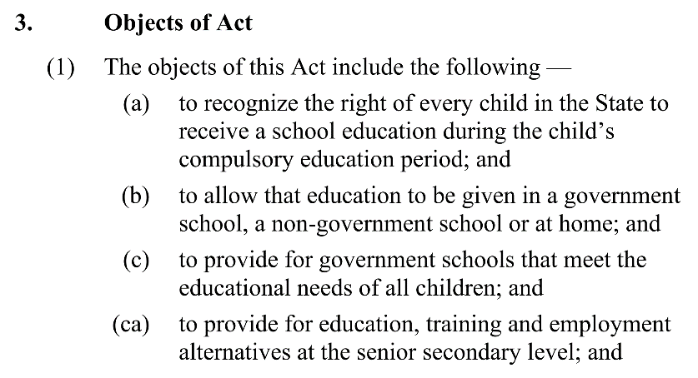

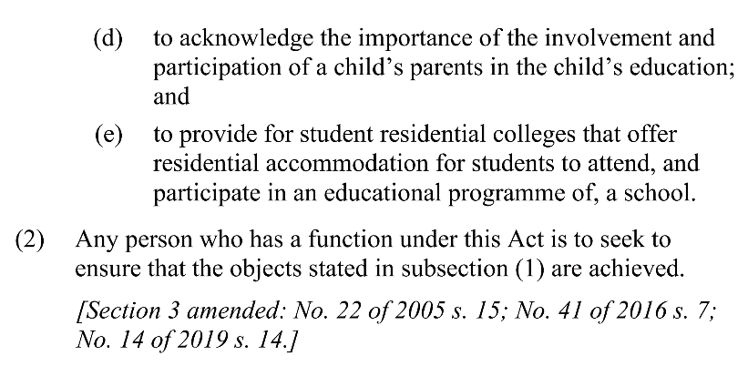

Source: Section 3: Objects of Act of the SE Act

Referring to Subsection (1a), the phrase “to recognise the right of every child in the State to receive a school education during the child’s compulsory education period” should be changed to add in the word ‘inclusive’ so that the sentence reads “to recognise the right of every child in the State to receive an inclusive school education during the child’s compulsory education period”. The term ‘inclusive’ should be defined using the United Nations framework of inclusive education from Article 24 of the Convention on the Rights of Persons with Disabilities and General Comment No. 4.
Referring to Subsection (1b), while this object is trying to respect ‘options’, what is important is that this object be qualified to ensure that all students have an accessible option of a mainstream government school, and how students and families shouldn’t feel that homeschooling or sometimes private schooling in disability specific private schools is their only option. Paragraph (1b) essentially describes the options for education, but if government schools aren’t inclusive and accessible to disabled students, then that really isn’t an option. The paragraph should be amended so that not only does it “allow” for that education to be provided in government and non-government mainstream schools, but it ensures that they are both accessible and inclusive to all students.
Referring to Subsection (1d), the phrase “to acknowledge the importance of the involvement and participation of the child’s parents in the child’s education” should be changed to include the phrase “the child and the child’s parents” so it reads “to acknowledge the importance of the involvement and participation of the child and the child’s parents in the child’s education”, as ultimately it is the child who is the one in the classroom, and their needs and their voice should be acknowledged just as much as their parents. While the views of parents are relevant and important, it is critical to appreciate that not all parents understand disability or have direct experience of their child’s disability and that the right to an inclusive education is the right of the child. This is also supported by General Comment No. 4.
Referring to Subsection (2), there should be an increased definition and increased clarity on who the onus of responsibility falls upon to implement the objects of the SE Act. There should be a clear onus on different components of the Department of Education and schools to perform different functions to ensure that these objects are being met. There should be more specific clarity on responsibilities for school principals, for the overall department itself, and for classroom teachers. See Section 4 of Part 1 for greater detail.

Response to Question 2:
QUESTION: Should principles be added to the SE Act to improve access and inclusion? If so, what principles would you add?
Principles would be useful in providing more specific guidance to the Department of Education and to schools on how to ensure that all students realise their right to an inclusive education. While the objects of the SE Act should be amended to provide high level recognition of the importance of inclusive education and the associated rights of students, the inclusion of specific principles aligned with Article 24 of the Convention on the Rights of Persons with Disabilities and especially the more detailed guidance of General Comment No. 4 would be valuable to better ensure inclusive education principles are guiding the interpretation of the SE Act more generally and obligations and duties of the CEO of the Department of Education, school principals, teachers and other educators.
The principles, for example, should refer to inclusive teaching practices, Universal Design for Learning (UDL), the need to seek and respect student voice, inclusive education training and data collection – as well as the overarching principle that every child deserves an inclusive education.

Response to Question 3:
QUESTION: Should the definition of disability in the SE Act be changed to improve access and inclusion? If so, how?
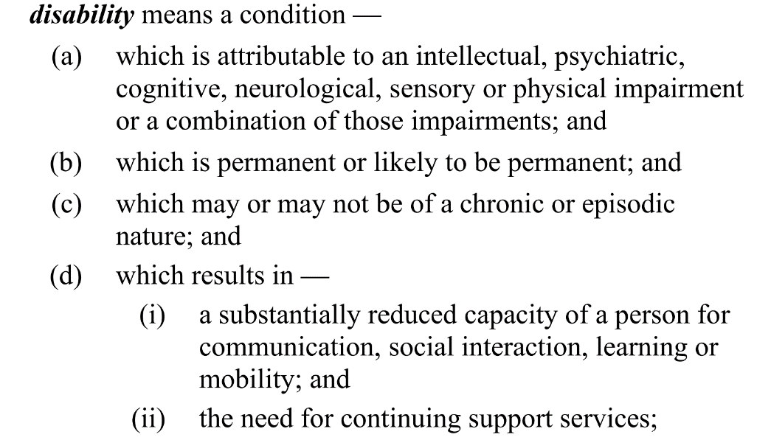

Source: definition of disability from the SE Act
The definition of disability should shift from the ‘medical model of disability’ and instead reflect the social model of disability. The medical model of disability, which can be seen in the current definition used in the SE Act, uses the idea that disability is a problem or a burden that an individual carries that inhibits their participation. The social model, however, describes the idea that an individual with impairments is ‘disabled’ by an environment with social, physical, attitudinal and communication barriers. This model, instead of putting the onus on disabled people to change themselves and their inherent characteristics, shows that it should be the systems and the social structures in place around disabled people, forming their environment, that should change to remove barriers.
The SE Act should adopt the same definition of ‘disability’ as the Convention on the Rights of Persons with Disabilities. In the CRPD, an explanation of disability is included in the preamble, rather than as a definition, but acts as a definition, nonetheless. It reads as follows.
Source: United Nations Convention on the Rights of Persons with Disabilities
disability results from the interaction between persons with impairments and attitudinal and environmental barriers that hinders their full and effective participation in society on an equal basis with others

Response to Question 4:
QUESTION: Should the SE Act change so that there is a clear right for students with disability to enrol at their local government school?
Yes, there should be a clear right for all students, including students with disability. See Section 2 of Part 1 under the subheading ‘A Clear Right to an Inclusive Education’.

Response to Question 5:
QUESTION: Should the SE Act provide greater flexibility in how students engage in education? If so, what should this look like?
Yes, there should be greater flexibility in how students engage in education. Schools need to be catering to the specific student, and their learning style, as ultimately, they are the ones receiving that education, so it needs to be delivered in a way that is accessible to them, and allows them to have good educational outcomes, and have their right to an inclusive education met.
While saying this, there should also be parameters placed on this flexibility, to ensure that what schools are delivering falls within the definition of an ‘inclusive education’ more specifically, to ensure that flexibility isn’t being used as an excuse to push students out of the education system by suggesting or strongly prompting parents towards homeschooling or other methods in order to limit the time of students in the classroom.
The flexibility that should be implemented should be around making the classroom environment more accessible to students, so that they can access the inclusive education that they are guaranteed under the CRPD.
As discussed in Section 1 of Part 1 under the heading ‘Universal Design for Learning’, there should be more flexibility in schools to ensure that disabled students are able to access an education that meets their needs. This includes classroom activities that are set at the student’s level, while still following the topics and content set in the curriculum and adjustments in testing to ensure that the student has the ability to demonstrate their learning, these adjustments may include more flexibility around how understanding is communicated, for example, spoken, typed using a laptop instead of handwritten, extra time considerations, and any other accommodations the student may need to demonstrate their learning. It should also include chill out/quiet spaces for students who are overstimulated, breaks for students, different considerations surrounding post school pathways for students, and should include the innovative use of technology to help everyone participate meaningfully in the classroom.
A guiding principle for all of this should be the understanding that students all have different brains and that the model of education should be flexible to cater to the needs of the student – and that educators should work with students to find how to provide a high-quality education that is accessible to them, but that flexibility should be used to increase the inclusivity and accessibility of the classroom environment for the student.

Response to Question 6:
QUESTION: Should there be any changes to the SE Act regarding roles and responsibilities? If so, what should this look like?
Yes, there should. To see what this should look like, refer to Section 4 of Part 1 called ‘Clear Responsibility for Realising Inclusive Education’, which includes specific suggested amendments to the SE Act regarding roles and responsibilities embedded within the ‘functions’ sections of the Act.

Response to Question 7:
QUESTION: Should there be any changes to the SE Act regarding adjustments for students with disability and/or universal measures? If so, what should this look like?
Yes, there should be. To see what this should look like, refer to Section 1 of Part 1 from the heading ‘Universal Design for Learning’ onwards.

Response to Question 8:
QUESTION: Should there be any changes to the SE Act regarding duties to communicate, consult and/or collaborate with students with disability and their parents. If so, what should this look like?
Yes, there should be changes, see Section 3 of Part 1 under the heading ‘Obligation to Communicate, Consult and Collaborate with Students & Parents’ for more.
Response to Question 9:
QUESTION: Should there be any changes to the SE Act regarding discipline, suspensions or exclusions? If so, what should this look like?
Yes, there should be changes regarding discipline, suspensions or exclusion. The model of discipline in the education system needs to shift from using exclusions as a punishment and needs to start trying to find the root of the problem, and moving towards restorative justice practices, which help the individual to realise the consequences of their actions, and their effect, without just excluding them.
‘Behavioural problems’, as they are often viewed in the education system, are often just symptoms of students being overwhelmed, overstimulated and under-supported in the classroom, which can cause them to feel distressed.
Teachers and principals should:
- Work with students and families to understand why a student behaved in a certain way.
- Find out whether that behaviour was a reaction to their needs not being met, and the environment not being inclusive of them and the supports they need.
- Be actively involved in consulting families on how the environment can be made more inclusive for their child.
- Implement changes that make the learning environment more inclusive of the student.
- Not exclude students from the classroom, instead work with the student to help them understand their actions.
Restorative practices should be used to help students understand, rather than just excluding them from the education they are entitled to. Suspending and expelling students doesn’t change anything if students are simply going to come back to the same not inclusive schooling environment that caused them to ‘misbehave’ in the first place.
“It’s not fair to punish a kid for their neurochemistry, that’s just wrong. We need to instead of looking at behaviour as a problem, we need to look at it as a symptom of their needs not being met. Especially as someone with Pathological Demand Avoidance (PDA), I struggle when I’m not respected at school – I become more combative and I end up getting disciplined because I’m causing problems, when in fact, that’s just a reaction to the world. Behaviours aren’t problems, they’re symptoms, and we need to stop them at the root rather than just sending kids home for an indefinite period of time.”

- Sam, age 16
Response to Question 10:
QUESTION: Should there be any changes to the SE Act (or regulations) regarding restrictive practices? If so, what should this look like?
Yes, there should be changes. The SE Act currently contains no mention of restrictive practices, and, when referred to in regulations, are only in reference to physical restrictions.
The SE Act should eliminate all use of restrictions in Western Australian schools, as restrictive practices are infringements and often outright breaches of the rights and freedoms of students, specifically, their freedom of movement.
Schools should be places where students feel safe and comfortable, and by using inhumane restrictive practices and restraints, schools become a place that students fear, leaving students traumatised and education being tied to horrible experiences for those students, causing them to be more disengaged in class and having worse educational outcomes. Restrictive practices are also stigmatising and undermine the development of an inclusive and supportive school culture.
Restrictive practices are often forms of violence and restrictive practices need to be phased out. There are currently no regulations around restrictive practices other than physical restrictions, so there is nothing regulating the use of chemical restraints or any other restraints that may lead to human rights breaches when used.
There needs to be a clear plan to phase out the use of restrictive practices, and the SE Act should include a framework to do this and significantly reduce the use of these practices and restraints.

Response to Question 11:
QUESTION: Should there be any changes to the Disability Advisory Panel and/or Discipline Advisory Panel sections of the SE Act? If so, what should this look like?
Yes, there should be changes. To see more specific suggestion on how to change the functions of these two panels and their compositions, refer to Section 3 of Part 1 under the heading ‘The Disabilities Advisory Panel and Other Advisory Groups’.

Response to Question 12:
QUESTION: Should the SE Act change so complaints are handled in a different way? If so, what should this look like?
Complaints are currently not independently managed. Parents and students have the option of formally complaining to their schools, or to the Department of Education itself – but in either case, there is no independent body that is considering the matter. It is essentially a process of complaining about the system to the system itself.
Complaints should be independently reviewed and investigated, and the panel/body that reviews complaints should be comprised of individuals from different vulnerable groups within schools (i.e including people with disabilities who have experience within in the WA education system) to ensure that there is expertise and knowledge surrounding different situations that may have resulted in those complaints, and to provide broader perspectives.
For a good review process, the Australian Human Rights Commission says the following principals should apply:
- Fairness
- Confidentiality
- Transparency
- Accessibility
- Efficiency
To achieve fairness, there should be an extensive collection of evidence, to ensure that all parties involved are consulted, and the consultation is broad. This is crucial to make sure that the situation has been understood appropriately.
To achieve confidentiality, an independent body should conduct all reviews into complaints, and only the people who need to know about the complaint are informed of it – this is to protect them so that they aren’t discouraged from speaking out in future.
These processes and reviews of complaints should be transparent, so that the complainant is kept involved and knows that they’re complaint is being reviewed, so that they don’t lose hope in the process and come to a view that there is nothing that can be done to fix their/the child’s experience and rectify the situation, so they/the child again has access to an inclusive education.
Accessibility is beyond important in a complaints system. Everyone, of all capabilities, need to be able to access the system and be able to make a complaint, to ensure that no student is facing any complaint-worthy practices at school, but is unable to do anything about it. Complaint systems should be accessible to students, especially students with disability, and students should not be discouraged from complaining.
Efficiency is crucial to the complaints system. Complaints need to be reviewed in a timely manner – to ensure that there are not ongoing situations that remain unresolved, and to ensure that the process is not a draining experience for all involved, and that the time involved doesn’t affect the perception of the system’s merit.

Response to Question 13:
QUESTION: With all the changes you have suggested in mind, how can the government monitor what is happening and show things are improving?
The government can monitor the progress of realising inclusive education and show improvement by the increasing of data collection by the Department of Education, to ensure that the data of vulnerable student groups is collected and analysed to identify if there are improvements, and if so, what was working effectively to create those improvements, or, inversely, if there were any barriers or regressions in progress, and if so, why these occurred and what was creating these barriers to realising inclusive education.
Refer to Section 4 of Part 1 from the heading ‘Data Collection’ onwards for more specific recommendations about what type of data should be collected and how it should be collected to ensure that the government can monitor the progress and effectiveness of policy and practices on inclusive education.

Conclusion
We, the students who participated in the creation of this submission, want to stress how important it is that this review of the School Education Act 1999 results in amendments to the Act that are consistent with inclusive education frameworks and will help the Western Australian education system realise inclusive education. Australia promised to implement inclusive education when it ratified the Convention on the Rights of Persons with Disabilities on 17 July 2008. It has been 16 years since then, and it is time to ensure that students with a disability have their CRPD rights met, and that all students have access to a high quality, meaningful, inclusive education.
“I really hope that they do change it [the SE Act] because, at the moment, I know for me, that it’s very hard. Sometimes it feels like you’re just not included, which is pretty much what this thing [the review] is about, and it’s not okay to be feeling not included, because that’s not comfortable, and, as all schools say, school is a place to feel safe.”
- Matilda, age 11

