Section 1: Inclusion is for Everyone
Echoed throughout the video interviews was the idea that ‘inclusion is for everyone’ and that inclusion does not benefit only disabled students, but rather the larger student and even school community.
Inclusion is often discussed in a disability or minority focused lens. It’s discussed in the sense of changing a pre-existing education model to expand to capture other students, but that is much more characteristic of ‘integration’ than it is of true inclusion. Students want to see the framework of the education system change to see inclusion as the norm, to seeing the concept of including, understanding and supporting applied to all students, rather than just students with recognised disabilities or of minority group status. Students want to see a classroom that is welcoming, safe and valuing of every student, rather than a classroom that shifts to integrate a disabled student, without actually changing any of its underlying structure and issues that made it inaccessible in the first place.
“Everyone has the right to have education and have the same opportunities to learn. It doesn’t matter who we are or where we come from, we’re all humans and we all deserve to be treated with respect.”
- student, age 16
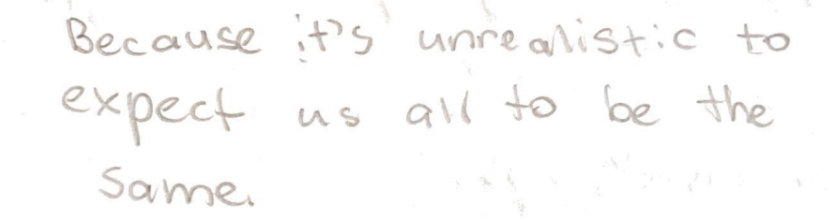

(Image: student has handwritten “Because it’s unrealistic to expect us all to be the same.”)
- student, age 13
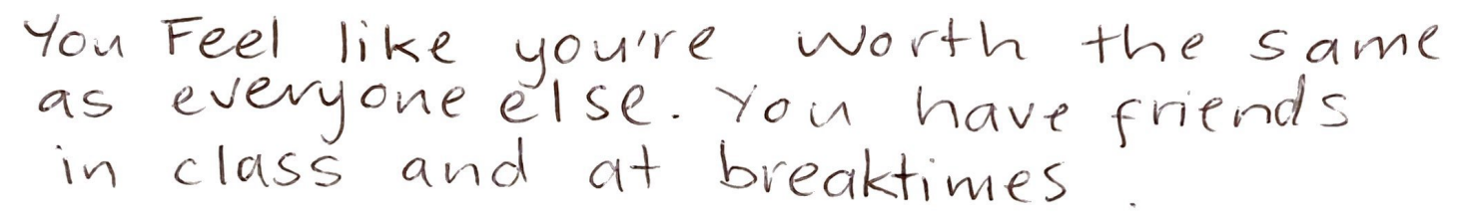

(Image: student has handwritten “you feel like you’re worth the same as everyone else. You have friends in class and at breaktimes.”)

- student, age 15

Universal Design for Learning (UDL) is key for this. To adapt to the model of inclusion that shows that inclusion is for everyone, schools should embrace Universal Design for Learning.

Universal Design for Learning (UDL)
[referencing Question 5 and 7*]
UDL describes the idea that the education system should be universally accessible and inclusive of every student, and that this should be reflected in the practices of schools.
All classroom activities should be accessible to all students. It should not be a matter of changing the classroom upon the arrival of a disabled student, rather, as a base, the classroom should be welcoming, accessible and inclusive of every student. This should include:

Teacher Instruction that is Easily Understandable to All Students
Teachers should be using visual prompts and other methods to make the message clear to all students. Instruction should not be overcomplicated, and teachers should be willing to explain instructions further if students require it.

Class Activities that Can Be Adjusted to Fit the Needs of the Student
Classroom activities should be set at the level of the students in the class. This means designing class activities through an inclusion lens and ensuring that the activities can be easily adjusted to fit the needs of the student, while still keeping all students learning on the same topic, so that they can interact with each other about the work and there isn’t a clear divide in who is doing what content. It’s differentiation, not completely different content.

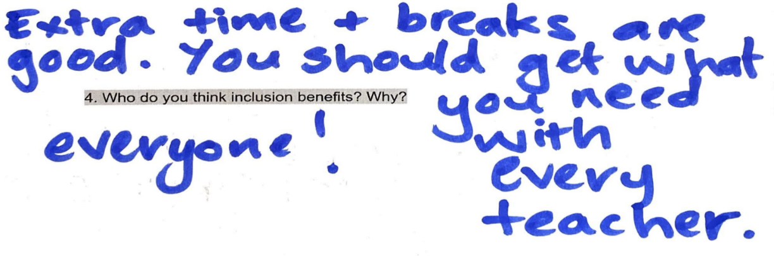

(Image: student has handwritten a response to the question “Who do you think inclusion benefits? Why?” and has written “Everyone! Extra time and breaks are good. You should get what you need with every teacher.”)
- student, age 12
“Fair isn’t all the same, it’s what you need.”

- student, age 9

Working with Students
Schools should work with students with disability, and all students, to understand what would make education more accessible and inclusive for that particular student. This should include consultations with the student and their family on a regular basis and making sure that classroom teachers are aware of the adjustments that should be made for the student and how to implement them well. Classroom teachers and disabled students should be actively involved in this process because ultimately, they are the ones in the classroom who will be implementing the ideas.
“I have felt very included this year by my teacher, because she is very flexible about decisions, and she lets us learn wherever we want in the class and lets us have brain breaks whenever we need them.”
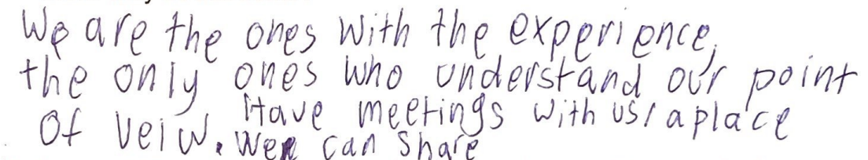
- student, age 8

- Mara, age 16
(Image: student has handwritten “We are the ones with the experience, the only ones who understand our point of view. Have meetings with us/a place of view we can share.”)
- student, age 16
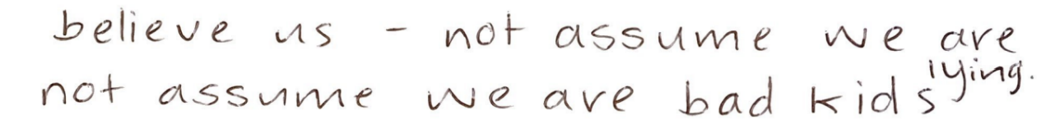

(Image: student has handwritten “believe us – not assume we are lying. Not assume we are bad kids.)
- student, age 13

Chill Out Spaces/Quiet Spaces
Ensure that the school environment has chill out spaces or quiet spaces for students to access when needed – not just necessarily students with disability. Chill out spaces provide students with a safe and calm environment for when they are overstimulated, and the classroom environment is inaccessible to them. While these spaces are very helpful and many students who participated described the benefits that chill out spaces have for them, these spaces should be complimentary to the classroom and should not replace the class environment. They should be accessed only when the classroom is not accessible for a student due to the student being overstimulated in that particular moment, but the classroom should be made as accessible as possible to minimise the time students spend in the chill out rooms. It should be an option for students, but schools should not push students to use that space instead of the classroom.

Considerations Surrounding Pathways
There should be a rethink around how schools prepare disabled students for meaningful employment, and how the system assesses students with standardised testing for post-secondary education.
Students would like to see a clear obligation on schools to work with students and families to create post-high school transition plans that lead to meaningful employment. Students want to see collaboration between themselves and their schools to create well thought out, inclusive pathways plans to ensure that their schools are preparing them for after their school years have ended. Students want to see schools helping students find real employment within their communities.
These transitions should not be planned at the last minute, but rather on a longer-term basis and as a dedicated plan – and those transitions not being towards shelter workshops or volunteer jobs, but rather towards real jobs, in the community, with real pay. Transition planning must be with high expectations and respecting the desires of the individual student. People with disability need to be economically secure too, and schools need to ensure that they are preparing students for economic security.
Additionally, schools need to be providing adequate adjustments for students to be able to take standardised tests, and other tests, such as WACE exams, to ensure that students with disabilities aren’t arbitrarily disadvantaged by a lack of accessibility. These tests can be incredibly important for all students in their goal of achieving economic stability, so it is crucial that these tests are accessible to all.
For in-school testing, students should not be disadvantaged by inaccessibility that teachers and the school itself could prevent by making reasonable adjustments for the student, such as extra time, different modes of answering (i.e. spoken answers, typed answers), breaks and other easily implemented adjustments.
For testing controlled by the Schools Curriculum and Standards Authority (SCSA), such as Online Literacy and Numeracy Assessment (OLNA) tests and Australian Tertiary Admissions Rank (ATAR) tests, it is essentially that SCSA, under the SE Act, is required to follow an inclusive education framework and principles to ensure inclusive and accessible outcomes for all students.
While other students often stress about their SCSA tests due to a lack of knowledge on their curriculum content, many students with disability instead have to fear lack of accessibility to demonstrate their knowledge, which is not something a student should have to worry about. If a student cannot demonstrate their learning on a test because the test is inaccessible, that disadvantages the student and puts them at an ‘unequal level’ relative to their peers. Especially for tests connected to ATAR, where students are ranked based largely on their end of year exam scores, if the exams themselves aren’t accessible, this puts the student on an unfair playing field, meaning not only do they have to study, but they have to do their best to battle within a system that was never designed to cater for their diverse needs.
SCSA must have an obligation to work with, not against, students with disability and their families to ensure that students are not disadvantaged by the systems they have in place, and SCSA must also have a requirement to facilitate any adjustments the student may need, in accordance with their right to an inclusive education. These tests, such as OLNA, are often crucial for a student to achieve their Western Australian Certificate of Education, so it is imperative that they are accessible to all students.
“I didn’t complete most tests and exams because I was running out of time. It wasn’t because I didn’t know the content, it was just simply that it took me a lot longer, and the time wasn’t enough. A lot of the time I would know the content, like in chemistry, most of the time I’d get about 90%, a pretty high grade, but when it came to the exam, I would get more like 60%, maybe in the 50s, just because I was not finishing it. It wasn’t because of the hard questions, because sometimes I would do those sometimes at the start, and it wasn’t about strategy because I was constantly working on how to get faster, and that’s what I talked about with my teachers. Always how do I do this faster; not how do I get better at this content. It was always about speed, and it was always very frustrating because I didn’t get to show what I knew or what I worked hard for, and I found it very unfair.
Accommodations are currently limited for students with disabilities. They need to be made more flexible to include things such as the use of laptop, even more extra time, or voice to text, to allow it to be more fair and reflective of what they can do.”

- recent high school graduate, age 18

