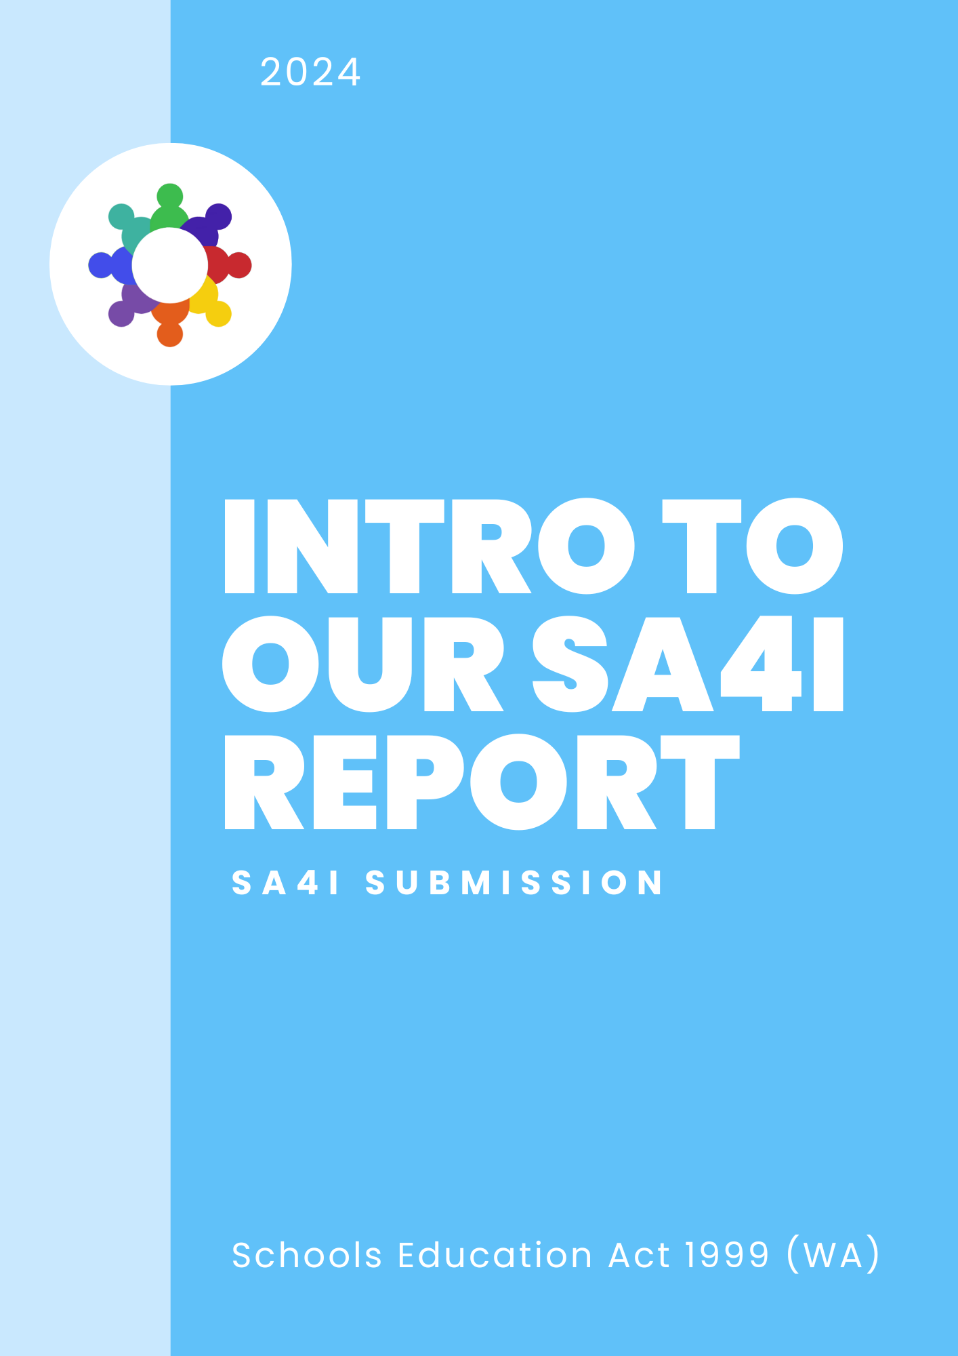

Introduction to the Organisers
This submission was written by the co-founders of the Student Alliance for Inclusion. Our names are Ruby Habib and Laura Panetta, and together with 27 other students with disability in Western Australian schools, we’ve collected authentic student voice about how the School Education Act 1999 (SE Act) should be amended to ensure the right to an inclusive education is met for all students.
Introduction to Ruby Habib: My name is Ruby Habib, I am sixteen years old and was born with a physical disability (congenital upper limb loss.) Currently in year 11, I have been progressing through the WA education system for over a decade and have experienced firsthand the positives and negatives of WA schooling. In my personal experience, I have faced many barriers regarding inclusion at school and have spent a lot of my childhood advocating for myself and my needs. I believe that everyone deserves a valuable and enjoyable school experience from kindergarten all the way through to year 12 and beyond, and it is my belief that this is possible with the right adjustments to the SE Act and the willingness and openness to change.
Introduction to Laura Panetta: My name is Laura Panetta, I am sixteen years old, and I am non-disabled, but I’ve always been really passionate about the rights of people with disability. My younger brother has Down Syndrome, so access to an inclusive education has always been something I’ve believed is essential to improve in Western Australia, to ensure realisation of the rights guaranteed to students with disability under the Convention on the Rights of Persons with Disabilities. I’ve lived most of my life watching my peers with disability having to fight within the system for there needs to be met, and I think that it’s time the SE Act is amended to recognise and welcome students with disabilities in the classroom and school community and realise their right to an inclusive education. I really believe student voice is so important in education, so I think that, by listening to the feedback and the voices of students, Western Australian’s education can be high quality, meaningful, accessible and inclusive for every student.
Participating Students:
Ruby, Laura, Emily, Matilda, Eleanor, Mimi, Robin, Sam, Daniel, Frank, Henry, Zeb, Julius, Tom, Sam, Drea, Cooper, Ryan, Ethan, Kayden, Wylder, Sofia, Luca, Mara, Natalya, Hayley, Zac, and two anonymous students

Introduction to the Project

Upon the announcement of the review of the SE Act 1999, we decided to create a submission with the participation of students from around WA to show the changes students believe need to be made to make the Western Australian education system accessible and inclusive of students with disabilities and provide them with meaningful and equitable education.
The submission was contributed to by 29 students, all of whom are actively supporting a change in the way the education system operates to include students with disability. The students all opted to either participate in a video interview, or to send us a written statement. All students who gave video interviews are in the video submission that accompanies this written submission, and students who sent us written statements may either have their voices heard in this written submission or the video.
The submission was entirely student run and only contributed to by students. All students who contributed are disabled, with the exception of Laura Panetta. The students wanted to showcase and highlight their own experiences as disabled students in Western Australia, as well as the pattern that all of their experiences together show – a pattern that highlights the dire need of WA schools to shift towards inclusive education. The students who contributed were between kindergarten age and year 12 age, with the exception of one ex-student who graduated in 2023.
Structure of the Written Submission: This written submission contains two parts. Part 1 is a summary of the areas students identified need to change within the education system, and Part 2 is more detailed, with specific answers to the questions provided in the Discussion Paper. In Part 2, there may be reference made to sections in Part 1, if the content of student feedback aligned strongly with the question.

Introduction to the Experiences of Disabled Students in WA
What this project found was the clear and resounding fact that many students in Western Australia are forced to choose between being included in the classroom and being supported in the classroom. Students detailed that their experiences of support and inclusion have been, largely, mutually exclusive in Western Australian schools, and that, in the rare instances that they have felt included and supported in the same environment, it is usually due to a certain teacher or group of school staff personally dedicated to inclusion – it isn’t the Department of Education structures that are facilitating the inclusion, rather it is the staff personally facilitating inclusion because it aligns with their personal values.
Students were also asked about the times at school when they felt the most included, and the students echoed the sentiment that they felt most included when they were supported to learn with their peers, disabled and non-disabled, and when their schools worked with them, instead of against them, to understand their needs and how to include them in the classroom, to help them achieve the best outcomes and access to highest quality education they could.
Students highlighted the barriers to even the most basic accessing of education in mainstream schools, with several students highlighting the number of schools who had told them that their mainstream school was not ‘the best fit’ for them. Some students participating are even homeschooled as the education system has pushed them out or provided such a low quality, often traumatising education, that they feel they cannot access an inclusive education at school, so the burden is put on the student and their parents to supply that education.
Students also drew attention to the idea that inclusion is for everyone, and that inclusion benefits all students, regardless of disability or not. Students spoke about making the schooling environment inclusive for all students, and setting inclusion as a basic standard of education, rather than an occasional ‘add-on’ for when a student doesn’t fit the ‘norm’.
Disabled voice in educational decision making was a key area that many students wanted to see improvement on. Students wanted to have more voice and agency, not only in their own education and in the way their schools work with them, and not against them, but also on a higher level. Students with disability want to see disabled people have input on Education Department wide decisions, and students with disability being consulted on significant issues. Disabled students want to have input at all levels and to have their voices and opinions genuinely taken into account.
All of this has been reflected throughout our video submission and will be addressed in more detail further in this written submission.

Introduction to the Importance of Change
Western Australian schools and the statewide education system do not cater for or include students with disabilities to a great extent. Listening to the voices of disabled people in this review of the SE Act is crucial to changing our education system for the better, as disabled people are ultimately the experts on disability and their own education, and they provide really valuable insights into the ways in which the system can be changed.
As of 2018, an estimated 1 in 10 students in Australia had a disability. This is likely a significant underestimate because disability is more than a medical label – what matters is how an individual student is affected by their learning environment and we all know that much more than 1 in 10 students need adjustments and support. The SE Act may only influence Western Australian students, but that is still a very large number of students who are affected daily and will go throughout the rest of their lives carrying the experiences they had in Western Australian schools. It is beyond important to ensure that the SE Act is inclusive of disability and sets in place a system wide framework that acknowledges, accepts and embraces the rights of disabled students to an inclusive education, so that every student in WA can receive a high-quality education, and be socially and academically supported.
PART 1
Insights Shared by Students
The following section is a summary of the main themes and messages expressed by students through the video interview process and the collection of written statements.
The ideas and the concepts in the following section were echoed across the entire student group participating, showing how deep and widespread the need for change is in Western Australian schools. Students came from a range of different schools, with different disabilities, and different experiences – but the desire to see reform remains consistent across the system.
Here are the messages echoed by students that will be discussed in Part 1:

Section 1: Inclusion is for Everyone
Section 2: The Choice Between Being ‘Supported’ and ‘Included’
Section 3: Valuing Authentic Disabled Student Voice
Section 4: Clear Responsibility for Realising Inclusive Education

